Treating Flea Infestations
Flea infestations can be a nuisance throughout the year. It is important to treat your pets with a reliable veterinary product and follow these simple steps to prevent this:
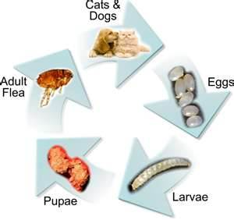
- Correctly apply a veterinary flea product to all cats and dogs in your home. Make sure you use the correct size for each animal’s weight. The product will kill fleas on the pet within 24-48 hours. It will not prevent new ones jumping on, but will continue to kill newly arriving fleas for several weeks.

- Vacuum the home thoroughly. Make sure you go under furniture and in nooks and crannies. Do this on wooden or laminate flooring as well as carpeted areas. This will remove some, but not all of the eggs, larvae and pupae. Remember to vacuum your vehicle if your pets travel with you.

- Wash pets’ bedding at 60to kill any of the immature stages of the flea.

- Encourage pupae to hatch. This is stimulated by warmth, vibration, carbon dioxide & humidity. Turning up the heating, placing damp towels on warm radiators and boiling the kettle may help with this.

- Thoroughly treat all the floor space in your home with insecticidal spray, (we recommend Indorex) Always read the instructions carefully. Again, it is important to cover all the areas where your pet goes, and don’t forget your car. Spraying your home kills eggs and larvae but not flea pupae.

- Ensure your pets have their usual run of the house. As fleas emerge from pupae they need to feed. If there are no pets around they will bite you.

- Continue to regularly vacuum your home.

- It may take several months to remove the infestation. Until the environment is free from eggs, larvae and pupae you will continue to see fleas on your pet.

- It is essential that you maintain regular treatment with a suitable veterinary flea product. Effipro and Indorex can be sold over the counter. More specialised products may be recommended by the vet. These include Advantix, Advocate Stronghold or Seresto collars.

6-8 weeks before you notice a flea
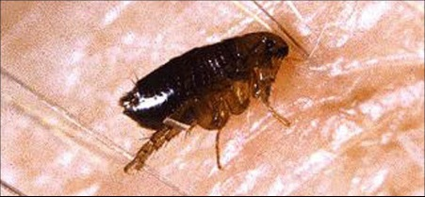

The groundwork for a home infestation
Flea infestations don’t happen overnight, they usually begin 6-8 weeks before you notice. Your unprotected pet brings in fleas from outside and once on your pet, they begin feeding and breeding. Before more obvious signs appear there can be thousands of eggs, larvae and pupae under your feet.

Month 1 of treatment
The flea population expands
As fleas in your home emerge, the flea problem may appear to be getting worse, but the infestation is actually running its course. Once you’ve applied a product, any fleas on your pet will be killed.

Your treated pets can still pick up fleas from outside, from your garden, from the park etc. At this time it is worth treating the home with a good quality household spray such as Indorex.

Month 2 of treatment
The infestation comes crashing down
Flea products work within 24-48 hours. Once all the developing fleas within the home have emerged the cycle is broken. This often happens in the second month following treatment.
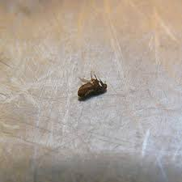

Month 3 of treatment
Your infestation is receding
You can’t prevent your pets from picking up new fleas. Therefore, it’s important you continue treating all cats and dogs in the home.

